**Wireframes**

The basic idea here is that the user should be able to create a todo list and add tasks to the list.

List List:

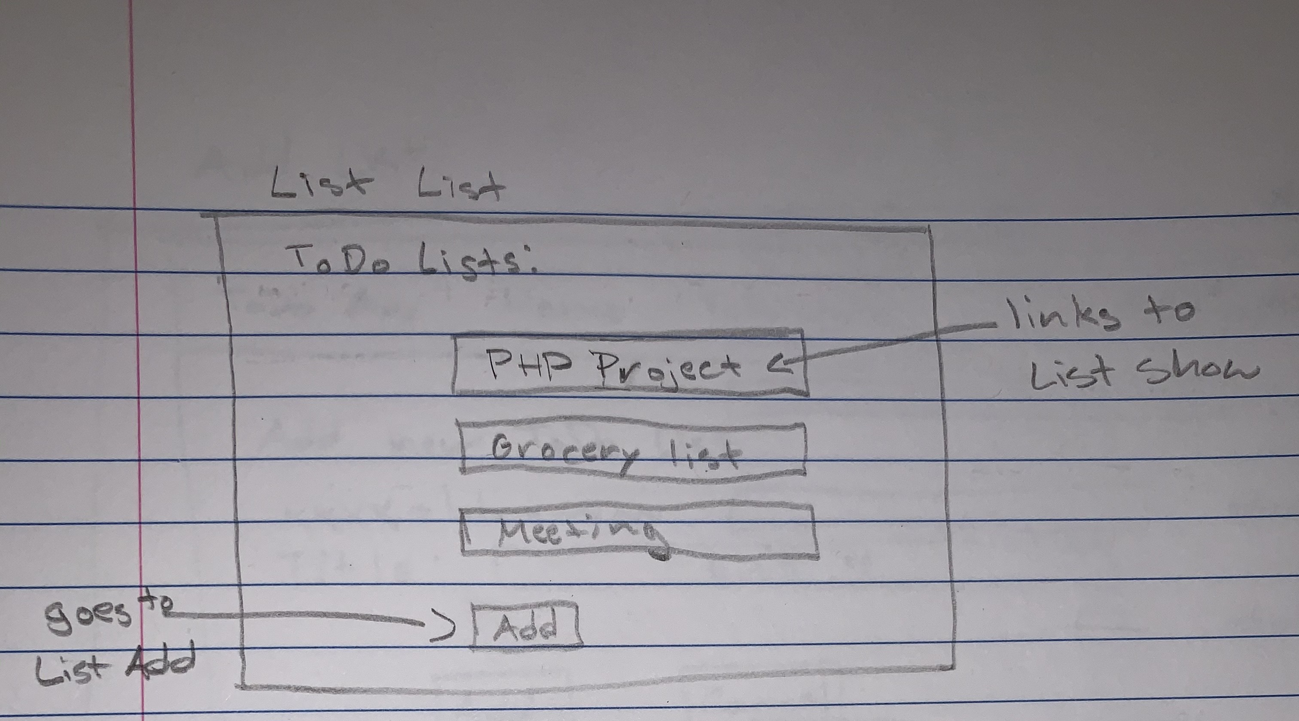

Here the user can see a list of all their existing lists and click “Add” to create a new one or click on one of the lists to see the detailed list view.

List Add:

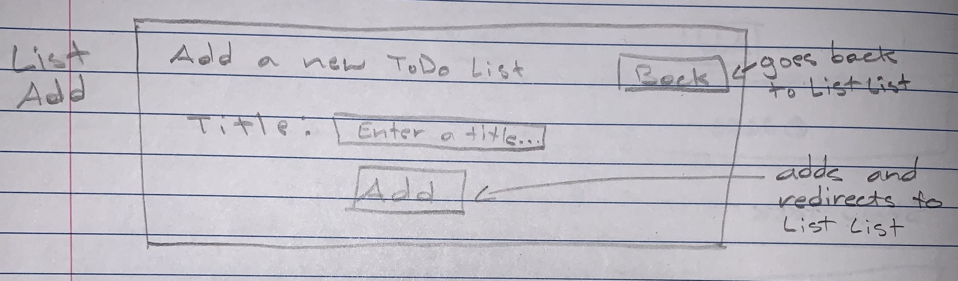

Here the user can enter a title for the list and click “Add” for the list to be created.

List Show:

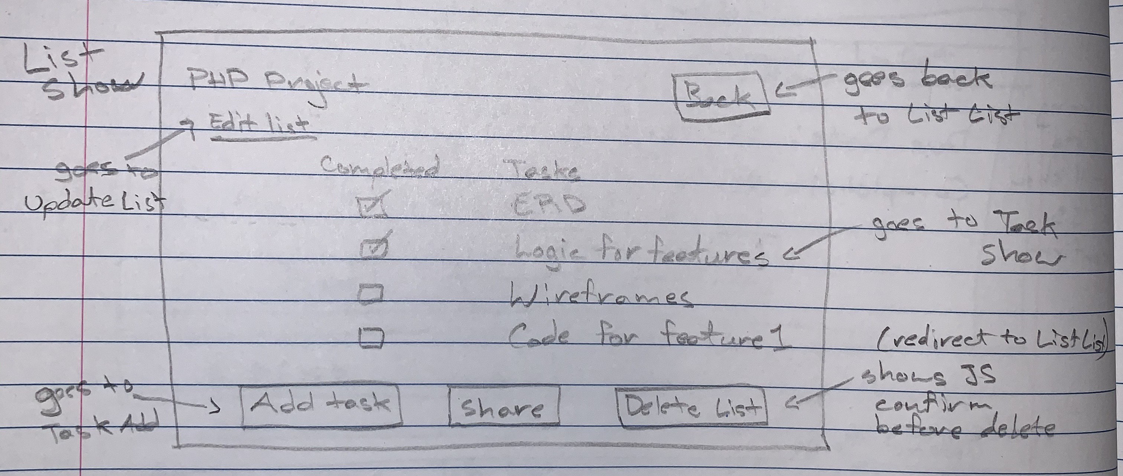

Here the user can see a list of tasks associated with the list. They can update the list by clicking “Edit list”. They can add a new task to the list by clicking “Add Task”. They can delete the list by clicking “Delete List”. They can click on one of the task to see the detailed task view. The “Share” button will take them to the Share page.

List Update:

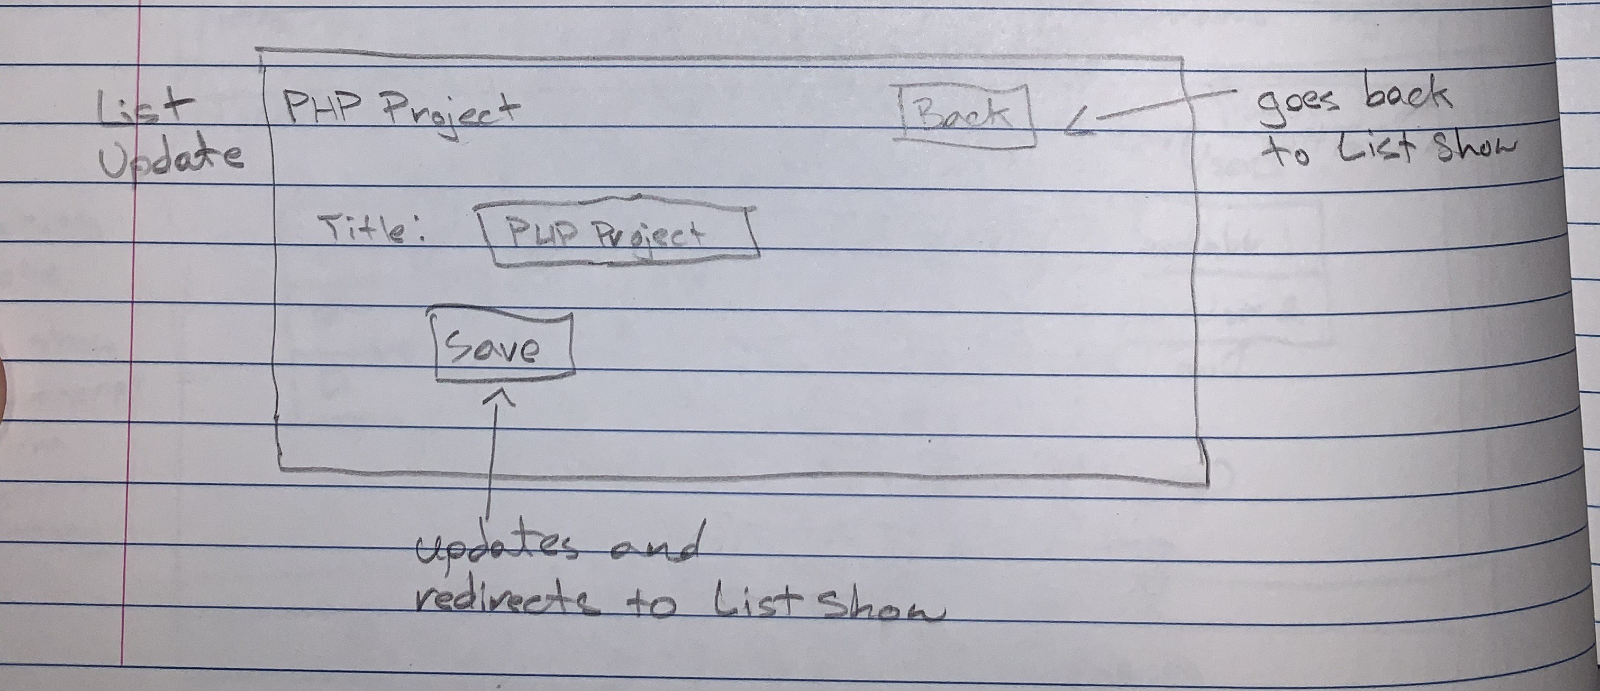

Here the user can change the list title.

Task Add:

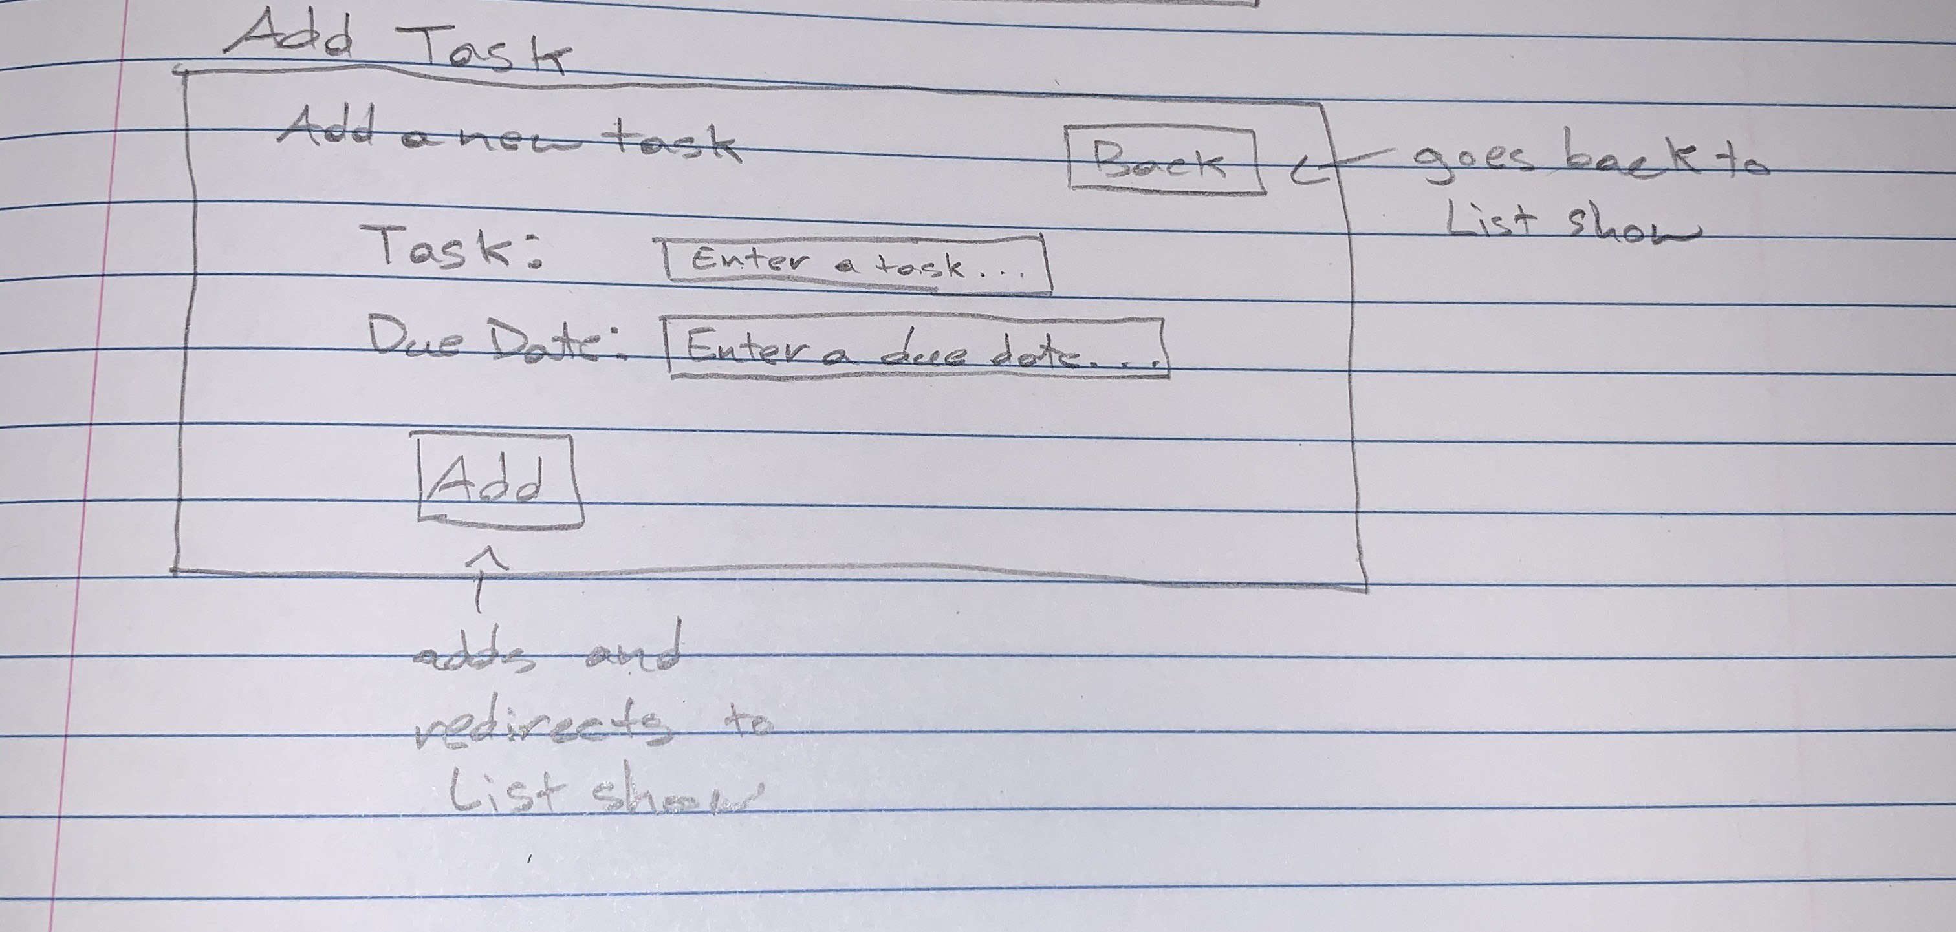

Here the user can create a new task. When a user is adding a new task it would be uncompleted. So the completed field should automatically be set to false so the user will not see the option on the Add Task page.

Task Show:

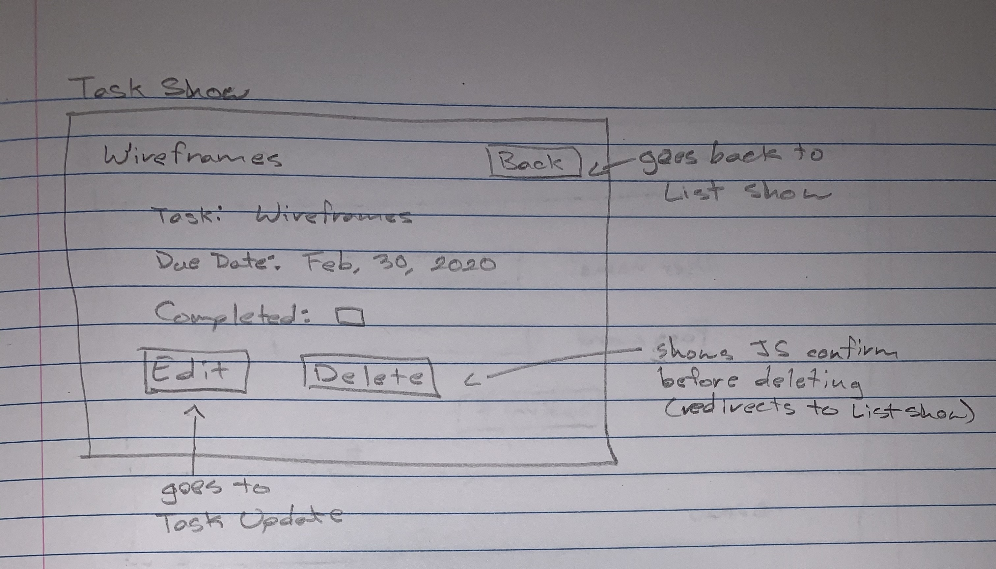

Here the user can see details for a specific task they clicked on. They can also edit it and delete it.

Task Update:

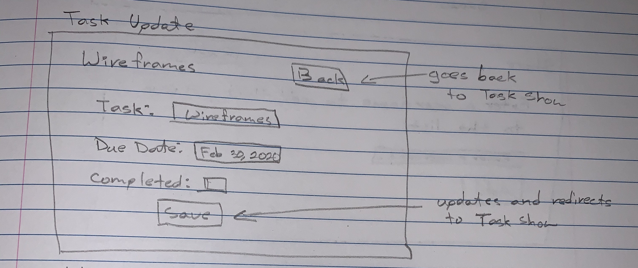

Here the user can edit a task. Now they have the option to set a task as completed.

Extensibility:

The “Share” button on the List Show page would be for inviting another person or multiple people to collaborate on a todo list. The page would ask the current user for a username or email and then the added user would be able to access the list. The page could look something like this:

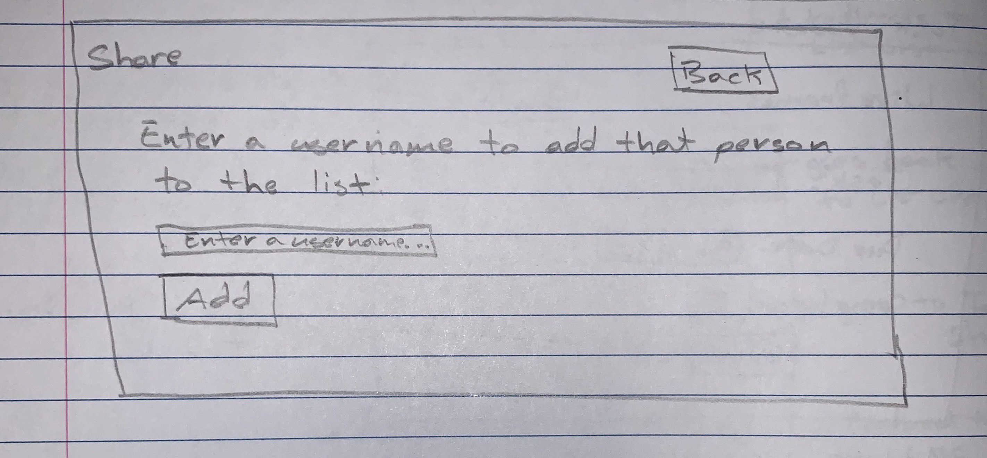

This means that there would also have to be a login system to 1) force a user to only see the lists they have created and 2) have a way to actually add a user to another list. The login page could look something like this:

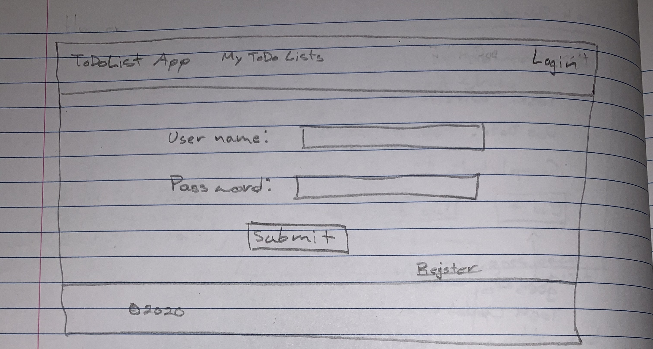

Note: This is what the header will look like. When a user is logged in they would see their username (which would link to a user dashboard) and a log out button in place of the login button.